**PROJECT DOCUMENTATION**

**DATE:** 20/12/2023

**PROJECT TITLE:** Health Insurance Analysis

**OBJECTIVE:** The goal of this data analysis project is to gain insights into the factors influencing health insurance charges. We aim to identify patterns, correlations, and trends that can help in understanding the key drivers of health insurance costs.

**INTRODUCTION:**

In an era where healthcare costs continue to be a significant concern, understanding the underlying factors that contribute to these expenses is crucial for informed decision-making and resource allocation. This data analysis project aims to shed light on the intricacies of healthcare charges by leveraging the power of Power BI and delving into a comprehensive dataset. The dataset encompasses diverse demographic and lifestyle factors, including age, sex, BMI, number of children, smoking status, region, and healthcare charges.

**DATASET DESCRIPTION:**

Age: age of the primary beneficiary

Sex: insurance contractor gender, female, male

BMI: Body mass index, providing an understanding of body, weights that are relatively high or low relative to height, objective index of body weight (kg / m ^ 2) using the ratio of height to weight, ideally 18.5 to 24.9

Children: Number of children covered by health insurance / Number of dependents

Smoker: Smoking

Region: the beneficiary's residential area in the US, northeast, southeast, southwest, northwest.

Charges: Individual medical costs billed by health insurance

**TOOLS**

1. **Microsoft Excel:** Data Exploration, Data Cleaning and Preparation, Data Visualization, and Basic Analysis.
2. **Microsoft Power Query:** Data Transformation, and Data Integration.
3. **Microsoft Word:** Documentation and Reporting.
4. **Microsoft Power BI:** Data Visualization and dashboard.
5. **Microsoft PowerPoint:** Presentation of Findings.
6. **Microsoft Teams:** Collaboration, and Sharing Reports.

**METHODOLOGY**

* Data Cleaning
* Data Exploration
* Data Cleaning and Preparation
* Data Visualization and Dashboard
* Insights and Recommendations
* Conclusion

**DATA CLEANING:**

No missing values and outliers

**DATA EXPLORATION:**

* Dataset was loaded into PowerBI.
* Examine the number of rows and columns in the dataset to understand its size.

Number of rows: 1339

Number of columns: 7

* Review the data types of each column (e.g., numeric, categorical) to ensure they are assigned correctly.
* Calculate basic summary statistics (mean, median, standard deviation, min, max) for numerical columns to understand the central tendency and variability of the data.

**DATASET DISTRIBUTION:**

A significant portion of the customer base for the health insurance company falls within the age range of 18 to 25 years old.

Summary statistics of age column was calculated using DAX Functions:

1. Mean: 39.19

Mean(age) = AVERAGE(insurance[age])

1. Median: 39

Median(age) = MEDIAN(insurance[age]

1. Mode: 18

Mode (Age) = MINX(TOPN(1, ADDCOLUMNS(VALUES(insurance[age]), "percent", CALCULATE(COUNT(insurance[age]))),[percent],DESC), insurance[age])

1. Range: 46

RANGE(AGE) = MAX(insurance[age]) - MIN(insurance[age])

1. Q1: 26

Q1(AGE) = PERCENTILE.EXC(insurance[age], 0.25)

1. Q2: 39

Q2(AGE) = PERCENTILE.EXC(insurance[age], 0.5)

1. Q3: 51

Q3(AGE) = PERCENTILE.EXC(insurance[age], 0.75)

1. Standard deviation: 14.05

STANDARD DEVIATION(AGE) = STDEV.P(insurance[age])

1. Variance: 197.41

VARIANCE(AGE) = VAR.P(insurance[age])

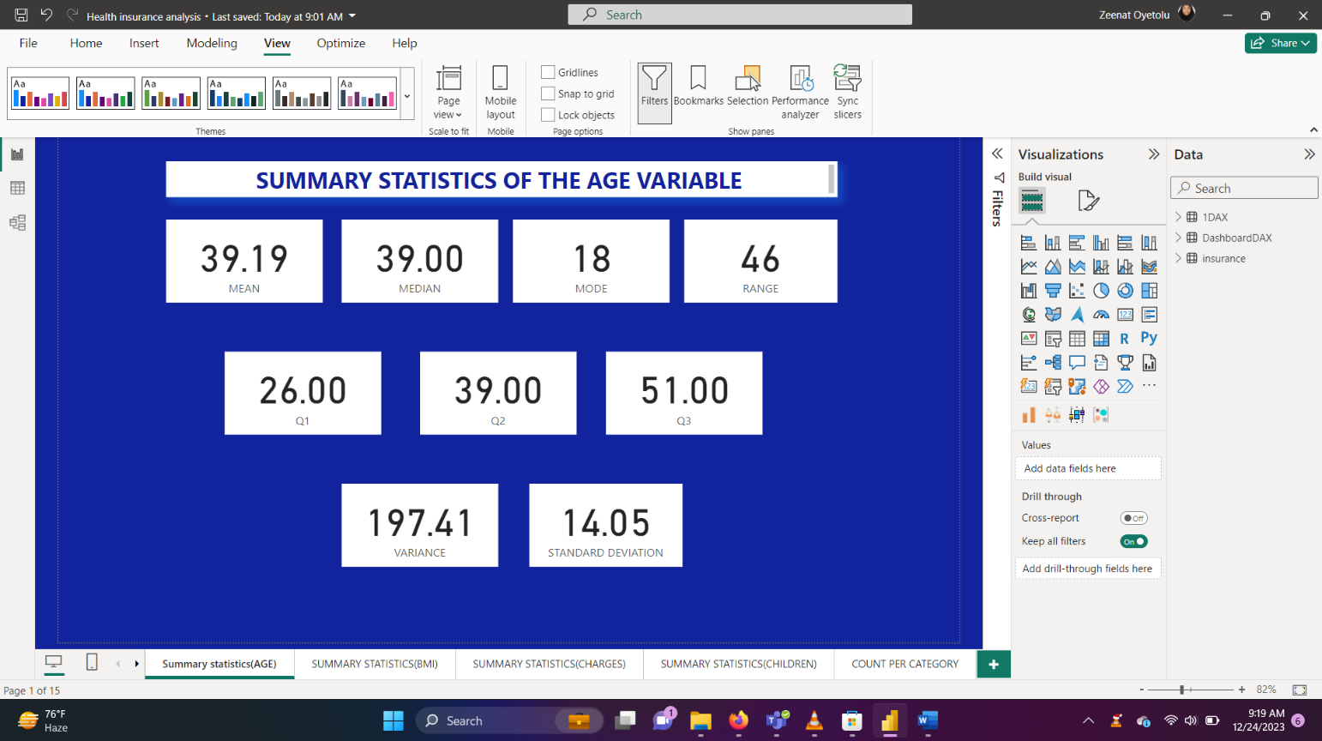

Summary statistics of BMI column was calculated using functions:

1. Mean: 30.66

Mean(BMI) = AVERAGE(insurance[bmi])

1. Median: 30.40

Median(BMI) = MEDIAN(insurance[bmi])

1. Mode: 32.30

Mode(BMI) = MINX(TOPN(1, ADDCOLUMNS(VALUES(insurance[bmi]), "percent", CALCULATE(COUNT(insurance[bmi]))),[percent],DESC), insurance[bmi])

1. Range: 37.17
2. Q1: 26.29

Mode(BMI) = MINX(TOPN(1, ADDCOLUMNS(VALUES(insurance[bmi]), "percent", CALCULATE(COUNT(insurance[bmi]))),[percent],DESC), insurance[bmi])

1. Q2: 30.40

Q2(BMI) = PERCENTILE.EXC(insurance[bmi], 0.5)

1. Q3: 34.70

Q3(BMI) = PERCENTILE.EXC(insurance[bmi], 0.75)

1. Standard deviation: 6.09

STANDARD DEVIATION(BMI) = STDEV.P(insurance[bmi])

1. Variance: 37.14

VARIANCE(BMI) = VAR.P(insurance[bmi])

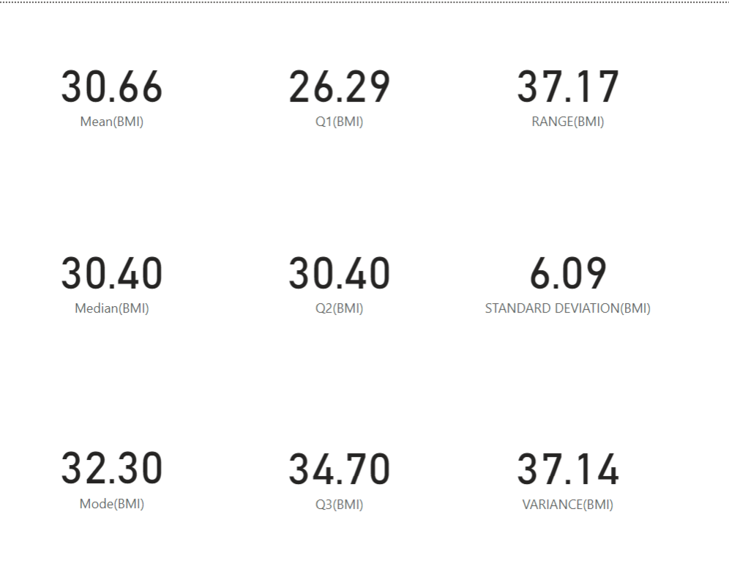

Summary statistics of charges column:

1. Mean: $13270

MEAN(CHARGES) = AVERAGE(insurance[charges])

1. Median: $9390

MEDIAN(CHARGES) = MEDIAN(insurance[charges])

1. Mode: $1640

Mode(CHARGES) = MINX(TOPN(1, ADDCOLUMNS(VALUES(insurance[charges]), "percent", CALCULATE(COUNT(insurance[charges]))),[percent],DESC), insurance[charges])

1. Range: $62650

RANGE(CHARGES) = MAX(insurance[charges]) - MIN(insurance[charges])

1. Q1: $4740

Q1(CHARGES) = PERCENTILE.EXC(insurance[charges], 0.25)

1. Q2: $9390

Q2(CHARGES) = PERCENTILE.EXC(insurance[charges], 0.5)

1. Q3: $16780

Q3(CHARGES) = PERCENTILE.EXC(insurance[charges], 0.75)

1. Standard deviation: $12100

STANDARD DEVIATION(CHARGES) = STDEV.P(insurance[charges])

1. Variance: $146.44M

VARIANCE(CHARGES) = VAR.P(insurance[charges])



Summary statistics of children column was calculated using measures:

1. Mean: 1.09

Mean(CHILDREN) = AVERAGE(insurance[children])

1. Median: 1

Median(CHILDREN) = MEDIAN(insurance[children])

1. Mode: 0

Mode(children) = MINX(TOPN(1, ADDCOLUMNS(VALUES(insurance[children]), "percent", CALCULATE(COUNT(insurance[children]))),[percent],DESC), insurance[children])

1. Range: 5

RANGE(CHILDREN) = MAX(insurance[children]) - MIN((insurance[children]))

1. Q1: 0

Q1(CHILDREN) = PERCENTILE.EXC(insurance[children], 0.25)

1. Q2: 1

Q2(CHILDREN) = PERCENTILE.EXC(insurance[children], 0.5)

1. Q3: 2

Q3(CHILDREN) = PERCENTILE.EXC(insurance[children], 0.75)

1. Standard deviation: 1.2

STANDARD DEVIATION(CHILDREN) = STDEV.P(insurance[children])

1. Variance: 1.45

VARIANCE(CHILDREN) = VAR.P(insurance[children])



* Count the unique values in categorical columns to understand the diversity of the data and identify potential issues.

Count of unique values in sex column:

Male: 676

Female: 663



Count of unique values in smoker column:

Smokers: 274

Non-smokers: 1065



Count of unique values in region column:

Southwest: 326

Southeast: 364

Northwest: 325

Northeast: 324



* Create **histograms or box plots** to visualize the distribution of numerical variables. This helps identify skewness or outliers.
* Use visualizations or statistical methods to detect **outliers** in numerical data. Decide whether to keep, transform, or remove outliers based on the context of the analysis.

Histograms and box plots of Age

Histograms and box plots of BMI

Histograms and box plots of children

Histograms and box plots of charges

* Use **scatter plots, correlation matrices, or pair plots** to investigate relationships between numerical variables.

Relationships between Age and BMI:

Relationships between Age and children:

Relationships between Age and charges:

Relationships between BMI and children:

Relationships between BMI and charges:

Relationships between children and charges:

**CORRELATION ANALYSIS**

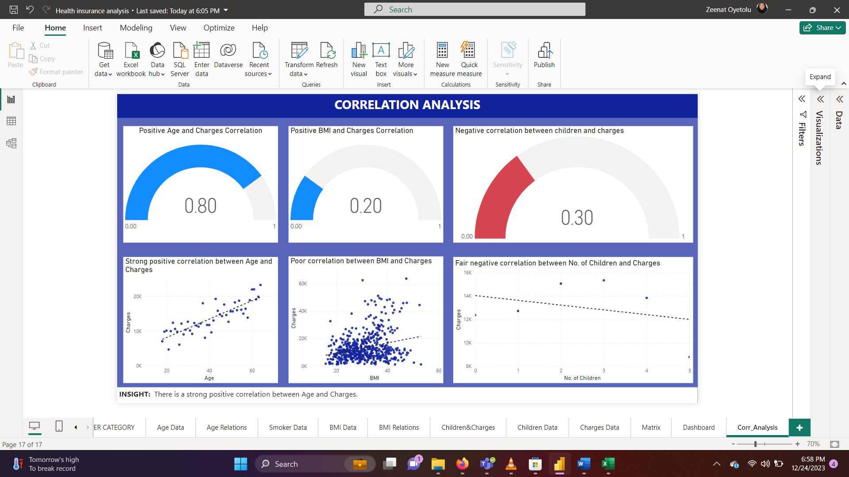

**DATA ANALYSIS:**

1. A new table was created for the measures.
2. Write a DAX measure for average charges, in the insurance table.

avg_charges =

CALCULATE(

    AVERAGE('insurance'[charges])

)

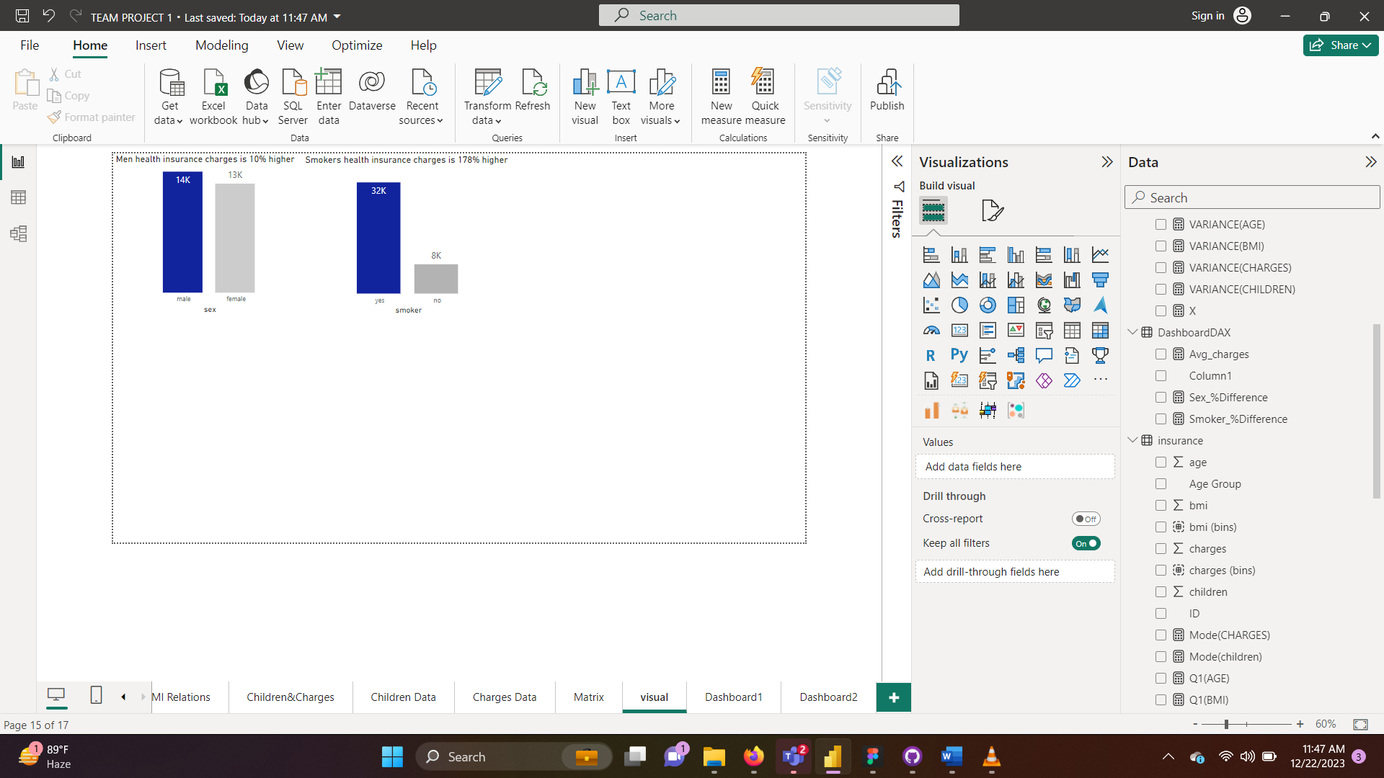

1. Write a DAX measure to calculate the percentage difference, in the insurance table, for the smoker column and visualize.

Smoker_%Difference =

VAR AvgChargesSmokers = CALCULATE(AVERAGE('insurance'[charges]), 'insurance'[smoker] = "yes")

VAR AvgChargesNonSmokers = CALCULATE(AVERAGE('insurance'[charges]), 'insurance'[smoker] = "no")

RETURN

    DIVIDE(AvgChargesSmokers - AvgChargesNonSmokers, [Avg_charges], 0)



1. 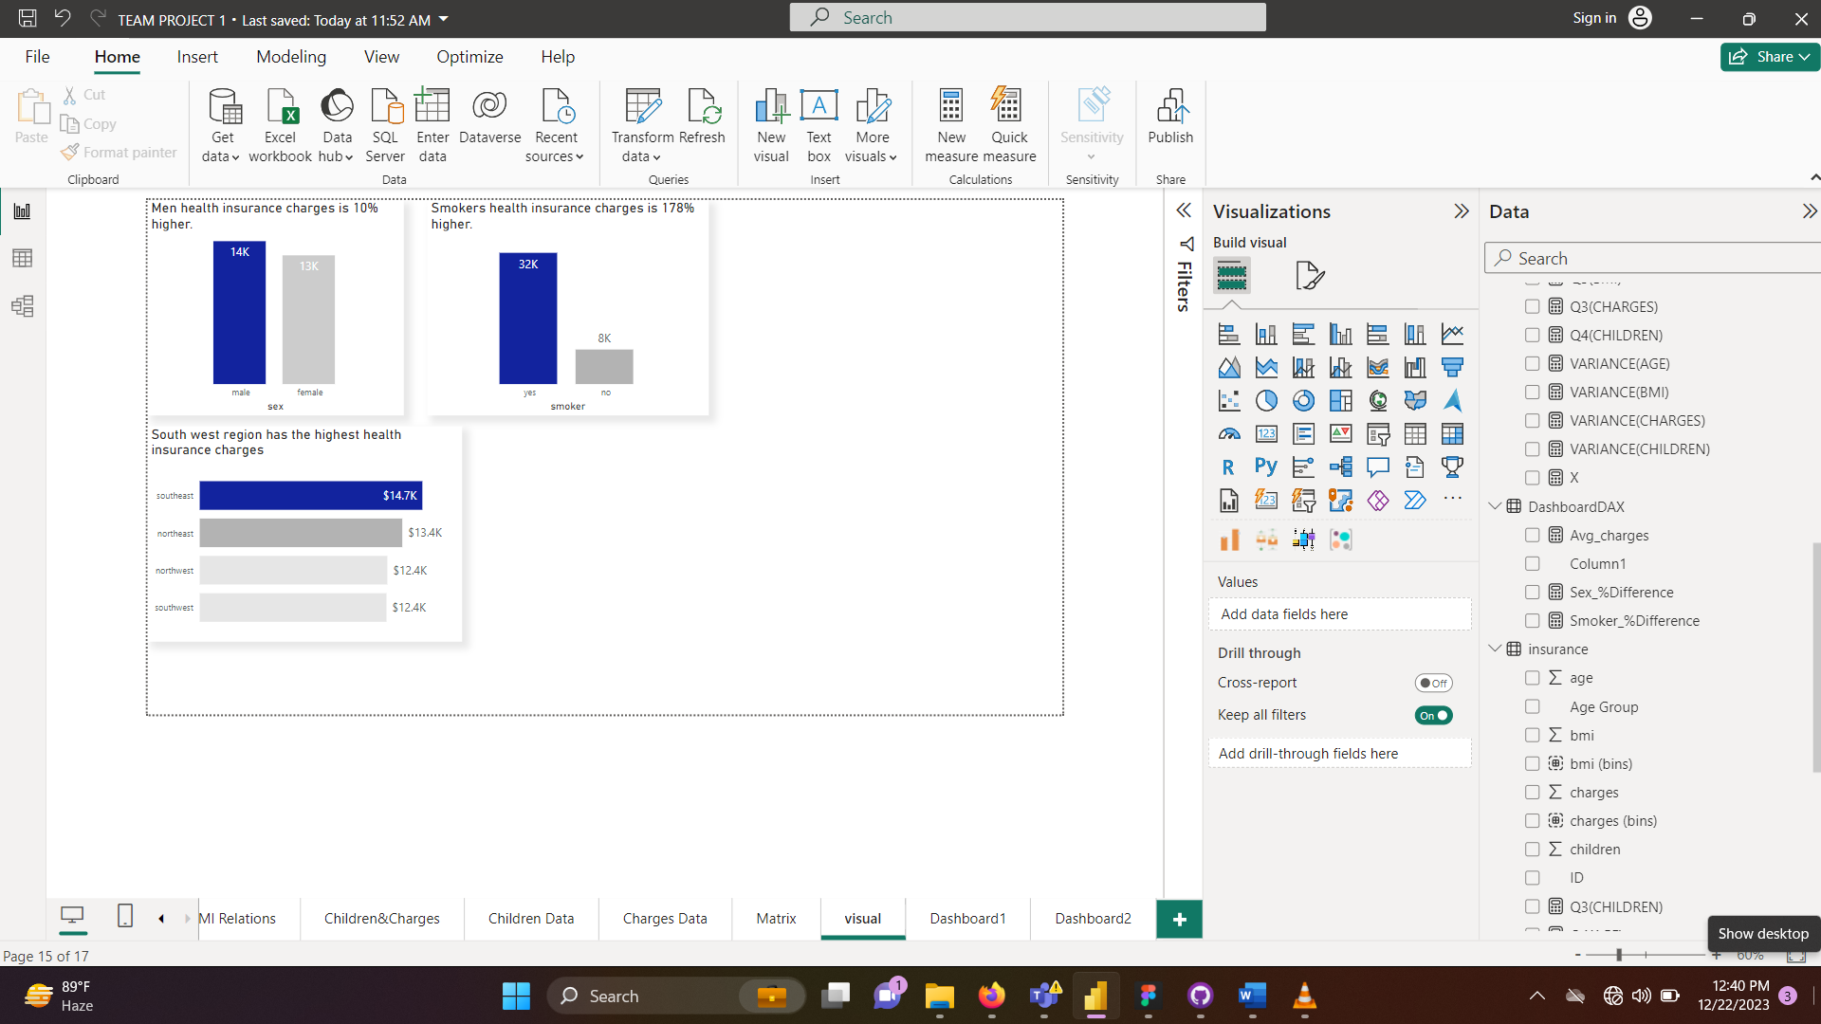Visualize average charges per region.
2. Created a new column Sexes = IF('insurance'[sex] = "female", "Female","Male")
3. Created a new column Smokers = IF('insurance'[smoker] = "no", "Non-smokers","Smokers")
4. Write the DAX formula for an age bracket column. The age bracket column will group the age column into 18-25, 26-35, and 36-45, 46-55, 56-65 in the insurance table, for the age column and visualize.

AgeBracket =

SWITCH(

    TRUE(),

    'insurance'[age] >= 18 && 'insurance'[age] <= 25, "18-25",

    'insurance'[age] >= 26 && 'insurance'[age] <= 35, "26-35",

    'insurance'[age] >= 36 && 'insurance'[age] <= 45, "36-45",

    'insurance'[age] >= 46 && 'insurance'[age] <= 55, "46-55",

    'insurance'[age] >= 56 && 'insurance'[age] <= 65, "56-65",

    "Other"

)

1. **BMI classification according to the National Institute of Health:**

• Severely underweight - BMI less than 16.5kg/m^2

• Underweight - BMI under 18.5 kg/m^2

• Normal weight - BMI greater than or equal to 18.5 to 24.9 kg/m^2

• Overweight – BMI greater than or equal to 25 to 29.9 kg/m^2

• Obesity – BMI greater than or equal to 30 kg/m^2

BMI Class =

SWITCH(

    TRUE(),

    'insurance'[bmi] <= 18.4, "Under-weight",

    'insurance'[bmi] >= 18.5 && 'insurance'[bmi] <= 24.99, "Normal-weight",

    'insurance'[bmi] >= 25 && 'insurance'[bmi] <= 29.99, "Over-weight",

    'insurance'[bmi] >= 30 && 'insurance'[bmi] <= 54, "Obesity",

    "Other"

)

**DASHBOARD**

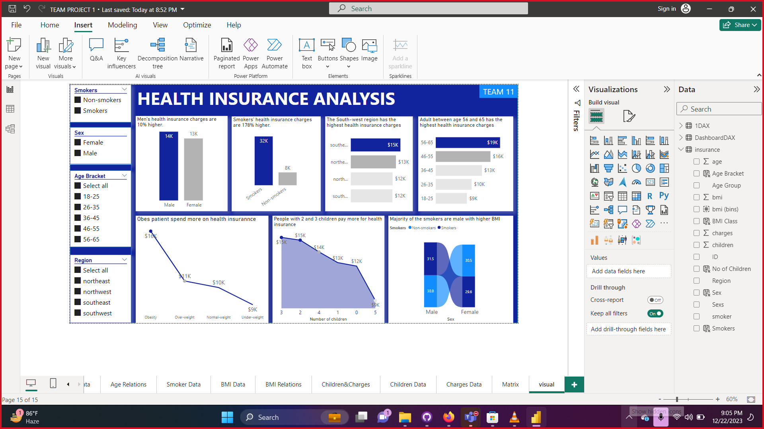

**INSIGHTS**

* Men's health insurance charges are 10% higher.
* Smokers' health insurance charges are 178% higher.
* The South-west region has the highest health insurance charges.
* Obese patient spends more on health insurance.
* People with 2 and 3 children pay more for health insurance.
* Majority of the smokers are male with higher BMI.
* Most of the health insurance customers have no children.

**INSIGHTS**

A significant portion of the customer base for the health insurance company falls within the age range of 18 to 25 years old.

**RECOMMENDATIONS**

Develop insurance plans that cater specifically to the healthcare needs and preferences of individuals in the 18 to 25 age group. This might include coverage for preventive care, mental health services, and options for fitness and wellness programs.

**RECOMMENDATIONS**

* **Targeted Marketing:**
  + Consider targeted marketing strategies for men, as they tend to have higher health insurance charges. This could involve tailoring advertising or promotional campaigns to appeal specifically to male demographics.
* **Smoking Cessation Programs:**
  + Develop and promote smoking cessation programs or health initiatives to reduce smoking rates among the insured population. This could potentially lead to lower health insurance charges for both individuals and the insurance provider.
* **Regional Pricing Strategies:**
  + Investigate the reasons behind the higher health insurance charges in the South-west region. Explore whether regional health factors, healthcare infrastructure, or other variables contribute to the increased costs. Adjust pricing strategies accordingly.
* **Wellness Programs for Obesity:**
  + Implement wellness programs targeting obesity. Providing resources and incentives for policyholders to adopt healthier lifestyles may lead to lower health insurance charges over time.
* **Family Planning Education:**
  + Develop educational programs or materials on family planning to inform individuals with 2 or 3 children about potential health insurance cost implications. This could include promoting family planning services or policies that address the needs of families with multiple children.
* **Smoking and BMI Interventions:**
  + Target interventions towards male smokers with higher BMI. Implementing programs that address both smoking cessation and weight management may have a positive impact on health outcomes and insurance charges.
* **Customized Insurance Plans:**
  + Consider offering customized insurance plans that cater to the specific needs and characteristics of different customer segments. This could involve creating plans tailored for non-smokers, individuals with no children, or those with specific health concerns.
* **Customer Education:**
  + Provide educational materials or workshops to inform customers about the factors influencing health insurance charges. This transparency can build trust and help customers make informed decisions about their insurance coverage.
* **Data Collection and Analysis:**
  + Continuously gather and analyze data to monitor trends and identify new insights. Regularly updating the analysis will enable the insurance provider to adapt strategies based on evolving customer behaviors and market conditions.
* **Customer Surveys:**
  + Conduct customer surveys to gather feedback on insurance preferences, challenges, and expectations. This information can be valuable in refining existing insurance plans and developing new offerings that better meet customer needs.